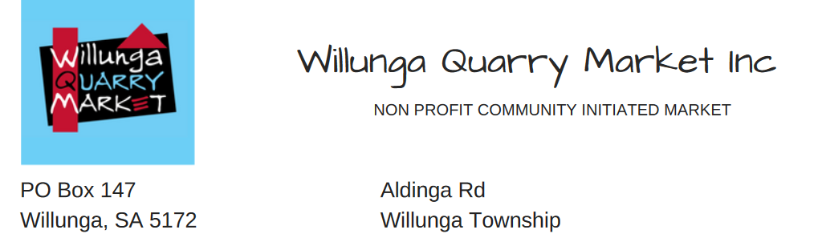

SITE FEES
There are 2 options available:-
Permanent stallholders may choose Option 1 OR 2
Seasonal and Casual stallholders can only opt for Option 2

Option 1
1. Sites
▪ 12 markets @ $15.00 per single site = $180.00 per annum or
▪ 6 markets @ $18.50 per single site = $111.00 per half year
▪ 1½ sites are 1½ times this = $270.00 and $166.50 respectively
▪ Double sites are double price = $360.00 and $222.00 respectively
2. Trestle
▪ $3.00 per unit. Trestles must be personally collected from and returned to the shed
3. Power
▪ $5.00 per site

Option 2
1. Sites
▪ Single site (4m x 4m) = $20.00 per market
▪ 1½ sites (6m x 4m) = $30.00 per market
▪ Double sites (8m x 4m) = $40.00 per market
▪ Shared sites (Single) = $15.00 per person
▪ Local charities and service clubs free
2. Trestle
▪ $3.00 per unit. Trestles must be personally collected from and returned to the shed
3. Power
▪ $5.00 per site

After you have paid your first site fee you will be given an envelope containing a receipt. In future markets your site fees for that day goes in the same envelope and is handed in to the Treasurer who will collect it and replace it with another envelope containing your receipt. Your payment should be ready for collection any time after 9.00am.
Please note that these fees are subject to review.

